**CONFIGURATION CHANGES AFTER INSTALLATION OF VISUALSVN SERVER**

Following are the step that was performed after installation of VisualSVN Server on all the 3 VisualSVN Servers i.e. SI0VM1678 (Master), FE0VM1424 (OSS Proxy FE) and KORVM079 (Proxy APAC)

* Setting Basic Authentication under Authentication Tab of Properties Window.

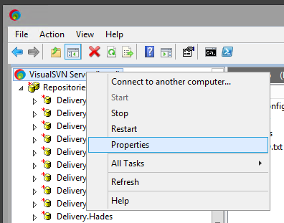

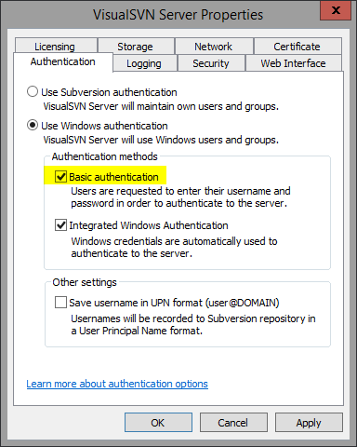

* Setting Server name as etassvn.de.bosch.com to the server and customize to use the “Empty URL prefix”

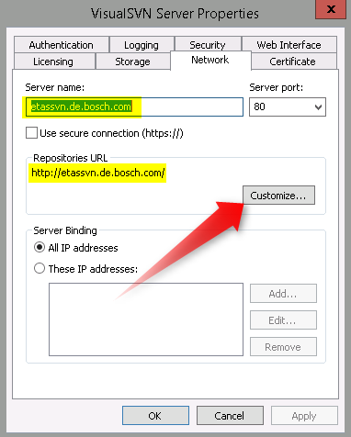

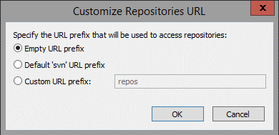

* Navigate to the VisualSVN folder and open the file "D:\apps\VisualSVN Server\conf\httpd-custom.conf" to add for following line "LimitRequestFieldsize 65535"

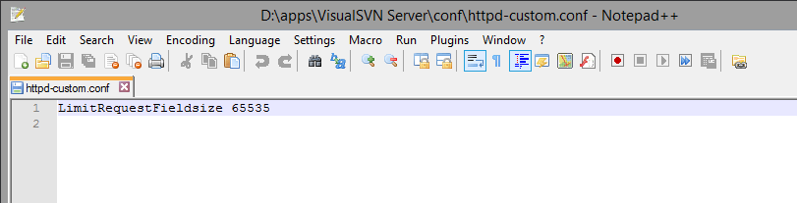

* Now, Configure the services under Services.msc
* Ensure that VisualSVN Server is configured to run using “Network Service” user, if not, please configure it.
* Also, Ensure that the VisualSVN Distributed File System Service (In short VDFS) is configured to run using the dedicated service account i.e. vmr6fe(Replication Service user SVN-VDFS-P)

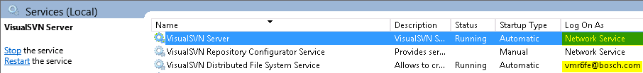

* Add that the local user “Network Service” has the following permissions on the repositories folder as shown in the below table.

|  |  |  |
| --- | --- | --- |
| **Path** | **Account** | **Permission** |
| D:\data\Repositories | Network Service | Modify |
| D:\ | Network Service | Read & Execute |
| D:\data\apps | Network Service | Read & Execute |
| D:\apps\VisualSVN Server | Network Service | Read & Execute |
| D:\apps\VisualSVN Server\certs | Network Service | Read & Execute |
| D:\apps\VisualSVN Server\bin | Network Service | Read & Execute |

* Also, Add the user vmr6fe to Edit Replication Partners & Edit Server Admins permissions under the Security tab for VisualSVN Server

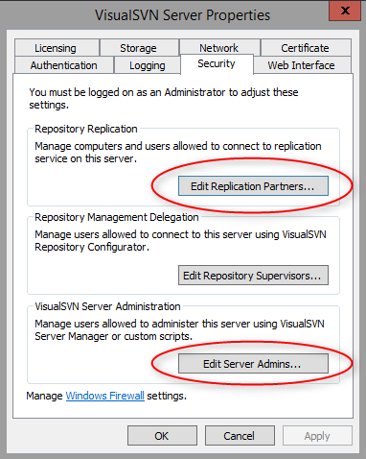

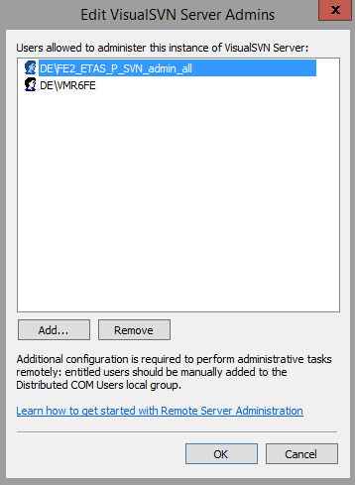

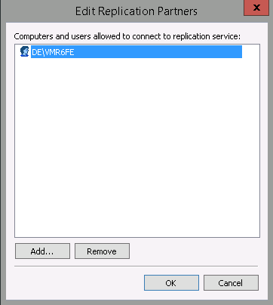

* Enable or configure the Windows Firewall for access between the master and slave for replication using VisualSVN VDFS functionality.
  + Goto Control Panel 🡪 All Control Panel Items 🡪 Windows Firewall
  + Click on “Allow an program or feature through Windows Firewall”
  + Using your admin privileges, Click on Change Settings
  + Check the boxes provided for VisualSVN Distributed File System Service and VisualSVN Server under Domain, Private and Public.
* After the above step, Enable the VDFS on the VisualSVN Server and it should be enabled without any error/issues.

